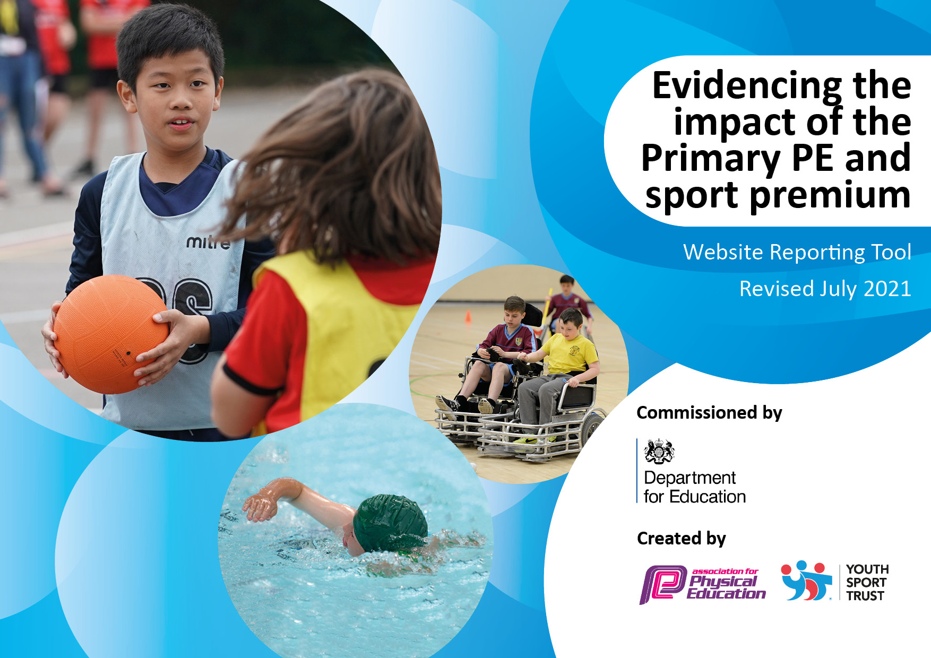
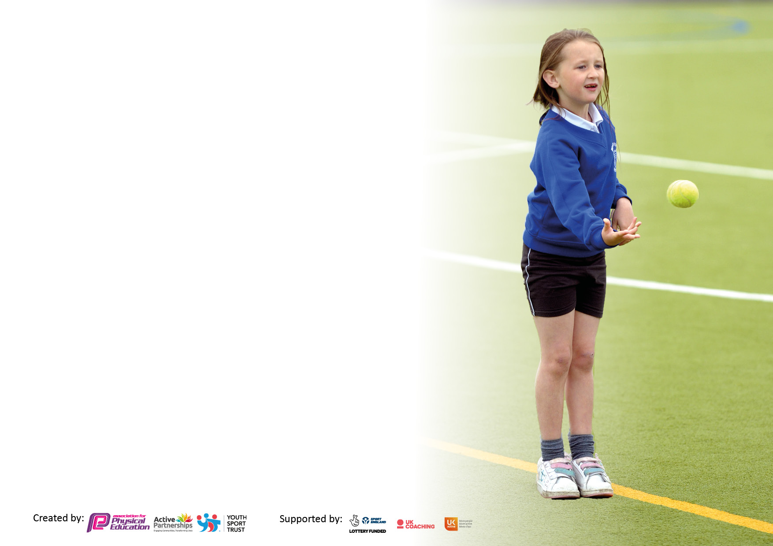

It is important that your grant is used effectively and based on school need. The Education Inspection Framework makes clear there will be a focus on ‘whether leaders and those responsible for governors all understand their respective roles and perform these in a way that enhances the effectiveness of the school’.

Under the Quality of Education Ofsted inspectors consider:
Intent - Curriculum design, coverage and appropriateness
Implementation - Curriculum delivery, Teaching (pedagogy) and Assessment
Impact - Attainment and progress

To assist schools with common transferable language this template has been developed to utilise the same three headings which should make your plans easily transferable between working documents.

Schools must use the funding to make additional and sustainable improvements to the quality of Physical Education, School Sport and Physical Activity (PESSPA) they offer. This means that you should use the Primary PE and sport premium to:

- Develop or add to the PESSPA activities that your school already offer
- Build capacity and capability within the school to ensure that improvements made now will benefit pupils joining the school in future years
- The Primary PE and sport premium should not be used to fund capital spend projects; the school’s budget should fund these.

Pleasevisitgov.ukfortherevisedDfEguidanceincludingthe5keyindicatorsacrosswhichschoolsshoulddemonstrate animprovement.Thisdocumentwillhelpyoutoreviewyourprovisionandtoreportyourspend.DfEencouragesschools to use this template as an effective way of meeting the reporting requirements of the Primary PE and sport premium.

We recommend you start by reflecting on the impact of current provision and reviewing the previous spend.

Schools are required to publish details of how they spend this funding, including any under-spend from 2019/2020, as well as on the impact it has on pupils’ PE and sport participation and attainment. All funding must be spent by 31st July 2022.

We recommend regularly updating the table and publishing it on your website throughout the year. This evidences your ongoing self-evaluation of how you are using the funding to secure maximum, sustainable impact. Final copy must be posted on your website by the end of the academic year and no later than the 31st July 2021. To see an example of how to complete the table please click HERE.
Created by: Supported by:

Details with regard to funding
Please complete the table below.

Total amount carried over from 2021/22 | £
Total amount allocated for 2021/22 | £ 17,750
How much (if any) do you intend to carry over from this total fund into 2022/23? | £
Total amount allocated for 2022/23 | £17,800
Total amount of funding for 2022/23. To be spent and reported on by 31st July 2023. | £17,800
Swimming Data
Please report on your Swimming Data below.

Meeting national curriculum requirements for swimming and water safety.

N.B. Complete this section to your best ability. For example you might have practised safe self-rescue techniques on dry land which you can then transfer to the pool when school swimming restarts.
Due to exceptional circumstances priority should be given to ensuring that pupils can perform safe self rescue even if they do not fully meet the first two requirements of the NC programme of study
What percentage of your current Year 6 cohort swim competently, confidently and proficiently over a distance of at least 25 metres?  N.B. Even though your pupils may swim in another year please report on their attainment on leaving primary school at the end of the summer term 2022.  Please see note above | 36%
What percentage of your current Year 6 cohort use a range of strokes effectively [for example, front crawl, backstroke and breaststroke]?  Please see note above | 18%
What percentage of your current Year 6 cohort perform safe self-rescue in different water-based situations? | 9%
Schools can choose to use the Primary PE and sport premium to provide additional provision for swimming but this must be for activity over and above the national curriculum requirements. Have you used it in this way? | No

Action Plan and Budget Tracking
Capture your intended annual spend against the 5 key indicators. Clarify the success criteria and evidence of impact that you intend to measure to evaluate for pupils today and for the future.

Academic Year: 2020/21 | Total fund allocated: | Date Updated:
Key indicator 1: The engagement of all pupils in regular physical activity – Chief Medical Officers guidelines recommend that primary school pupils undertake at least 30 minutes of physical activity a day in school |  |  |  | Percentage of total allocation:
 |  |  |  | 28%
Intent | Implementation |  | Impact
Your school focus should be clear what you want the pupils to know and be able to do and about  what they need to learn and to  consolidate through practice: | Make sure your actions to achieve are linked to your intentions: | Funding allocated: | Evidence of impact: what do pupils now know and what can they now do? What has changed?: | Sustainability and suggested next steps:
- To get more children active throughout the day  - Year 6 house captains to lead lunchtime activities  - Sports equipment to be well stocked and embedded during playtimes  - Introduction of physical activity into wrap around care (breakfast and afterschool) through PE lead upskilling TAs involved | - Train Year 5 in leadership and teamworking skills ahead of next year  - Year 6 trained in playground games  - Review of stock every term (Autumn 1, Spring 1, Summer 1) and to replenish stock when/if needed  - Train wrap around care staff in afterschool games  - To create a link between schools to share ideas and knowledge | £5000
Key indicator 2: The profile of PESSPA being raised across the school as a tool for whole school improvement |  |  |  | Percentage of total allocation:
 |  |  |  | 3%
Intent | Implementation |  | Impact
Your school focus should be clear what you want the pupils to know and be able to do and about  what they need to learn and to  consolidate through practice: | Make sure your actions to achieve are linked to your intentions: | Funding allocated: | Evidence of impact: what do pupils now know and what can they now do? What has changed?: | Sustainability and suggested next steps:
- Attending GSSP partnership workshops and CPD opportunities  - Teamwork and collaboration  - Increased competition and recognition of children’s achievements  - Problem-solving, children to organise and play together | - Cover needed to ensure visits to partnership schools  - Cover needed for PE lead to attend GSSP meetings and workshops to raise the profile of PESSPA  - Expenses of medals, cups and additional prizes | £500

Key indicator 3: Increased confidence, knowledge and skills of all staff in teaching PE and sport |  |  |  | Percentage of total allocation:
 |  |  |  | 49%
Intent | Implementation |  | Impact
Your school focus should be clear | Make sure your actions to | Funding | Evidence of impact: what do | Sustainability and suggested
what you want the pupils to know | achieve are linked to your | allocated: | pupils now know and what | next steps:
and be able to do and about | intentions: |  | can they now do? What has
what they need to learn and to |  |  | changed?:
consolidate through practice:
- Staff are supported to learn new skills through CPD opportunities delivered by the PE Lead and specialist teachers (e.g., gymnastics, dance)  - Teachers encouraged to attend lessons delivered by PE Lead  - Staff provided with the resources and training to support PE teaching to a competitive level through GSSP  - Cricket coaches are employed in Year 4 | - Become members of GSSP (Greenwich School Sport Partnership)  - Pay for specialist dance teacher to run dance curriculum (teacher observation to increase confidence)  - PE Lead to upskill through attending CPD opportunities and feedback to teaching staff  - Purchase of Get Set 4 PE scheme to support all teachers in delivering PE  - Observations and team teaching with specialist teachers empowers staff to learn new skills and share their own  - Cricket coaching in Year 4 (one term) taught by specialists and offering expended opportunities to play at clubs/competition | £8,700
Key indicator 4: Broader experience of a range of sports and activities offered to all pupils |  |  |  | Percentage of total allocation:
 |  |  |  | 15%
Intent | Implementation |  | Impact
Your school focus should be clear | Make sure your actions to | Funding | Evidence of impact: what do | Sustainability and suggested
what you want the pupils to know | achieve are linked to your | allocated: | pupils now know and what | next steps:
and be able to do and about | intentions: |  | can they now do? What has
what they need to learn and to |  |  | changed?:
consolidate through practice:
- Improve swimming outcomes for Year 4 children  - Increase sporting opportunities after school  - Provide orienteering and team building opportunities  - Provide a range of specialist sport activities for taster days and sessions  - Provide children with the space to enable an enriched sports day experience | - Year 4 to have intensive swimming course receiving 1 hour every day for two weeks  - Year 4 to have 1 swimming lesson per week for one academic year  - Trips to Reach (part of OAA)  - Trip to Shooters Hill Woodlands farm (orienteering)  - Improve extra-curricular opportunities on offer through links with associated clubs and societies  - Conduct pupil voice to find out what type of clubs’ pupils would like  - Particular focus on response from girls.  - Hiring the use of Sutcliffe Park grounds | £2,750

Key indicator 5: Increased participation in competitive sport |  |  |  | Percentage of total allocation:
 |  |  |  | %
Intent | Implementation |  | Impact
Your school focus should be clear | Make sure your actions to | Funding | Evidence of impact: what do | Sustainability and suggested
what you want the pupils to know | achieve are linked to your | allocated: | pupils now know and what | next steps:
and be able to do and about | intentions: |  | can they now do? What has
what they need to learn and to |  |  | changed?:
consolidate through practice:
- Organise and participate in sports activities and competitions across the partnership and Local Authority  - Get more children involved in competitive sport across different age groups | - Inter school competitions arranged every half term  - Sports Day at Sutcliffe Park  - Travel to competitions | £1000

Signed off by
Head Teacher: | Laura Collins
Date: | December 2022
Subject Leader: | Kate Green
Date: | December 2022
Governor:
Date:

